

**JAISHRIRAMENGINEERINGCOLLEGE TIRUPPUR – 638 660**

ApprovedbyAICTE,NewDelhi&AffiliatedtoAnnaUniversity,Chennai Recognized by UGC & Accredited by NAAC and NBA (CSE andECE)

**DEPARTMENTOF**

**ELECTRONICSANDCOMMUNICATIONENGINEERING**

**IBM-NaanMudhalvan**

**Internet ofThings–Group3**

**Phase5–SUBMISSION&DOCUMENTATION**

**PUBLICTRANSPORTOPTIMIZATION**

**NAME :Selvapriya S**

**NM ID :AU711221106031**

**YEAR :III**

**PUBLICTRANSPORTOPTIMIZATION**

**(**Documentation&submission**)**

# INTRODUCTION:

public transport optimization stands at the forefront of modern cityplanning. With the goal of enhancing the efficiency, accessibility, and environmentalsustainabilityofpublic transit systems, public transport optimization employs advanced technologies, data analytics, and innovative strategies to revolutionizethewaypeople movewithincities.Thispursuit ofexcellence inpublictransportationisnot onlyacatalyst for reduced congestionand emissions but also adriver ofeconomicgrowthand improved urban living. In this exploration, we delve into the multifaceted world of public transport optimization, uncovering the strategies and cutting-edge solutions that are shaping the future of urban mobility.

# PROJECT’SOBJECTIVES:

* RouteOptimization:

Develop algorithmsand strategiestooptimize public transport routesbased onpassenger demand,trafficconditions,andurbandevelopment,aimingtoreducetraveltimesandenhanceservice quality.

* SmartTicketingandFareSystems:

Upgradeticketingsystemstoenablecontactlesspaymentsanddynamicpricing, improving convenience for passengers and optimizing fare revenue.

* Real-timeInformationSystems:

Develop mobileappsand informationdisplaysthat providereal-timeupdatesonbus/train locations, arrival times, and service disruptions to enhance the passenger experience.

* DataAnalyticsandPredictiveMaintenance:

Utilizebigdataanalyticstopredictmaintenanceneeds,improveasset management,and anticipate passenger demand, leading to cost savings and enhanced service quality.

* ReducedEmissionsandElectrification:

Set goalsforreducingemissionsandtransitioningto electricorzero-emissionvehiclestoalign with sustainability objectives**.**

# IOTSENSORDEPLOYMENT:

* These sensors, strategically integrated across vehicles and infrastructure, provide real-time insights and data-driven solutions. Equipped on buses, trains, and at stations, IoT sensors monitor passengercounts,vehiclelocations,occupancyrates,andevenpredictmaintenanceneeds,enabling dynamic route adjustments and responsive scheduling.
* SurveillancecamerasandIoTsecuritysensorsenhancesafetyandsecurity,whiledataanalytics and predictive maintenance improve asset management and operational cost savings.
* This multifacetedapproach, drivenbyIoTsensor data,empowerspublictransport systemstobe moreagile,accessible,andenvironmentallysustainable,ultimatelyprovidingahigherqualityofservice to passengers and a smarter, greener future for urban mobility**.**

# PLATFORMDEVELOPMENT:

* This integrated platformleveragescutting-edge technologies, including data analytics, IoT sensors,AIalgorithms,andseamlesscommunicationsystems,toorchestrateasymphonyofpublic transport services.
* Itfacilitatesreal-timedatacollectionandanalysistooptimizeroutes,schedules,and maintenance, allwhile ensuring seamless passenger experiences withuser-friendlymobile apps, contactless payments, and real-time updates.
* Multimodalintegrationbecomesareality,bridgingbuses,trams,subways,andsharedmobility options, while fostering sustainability through green technologies and electrification.

# CODE IMPLEMENTATION:

ROUTE OPTIMIZATIONUSINGNETWORKS

Importnetworksasnx G.add_node(“stop A”) G.add_node(“stop B”)

G.add_edge(“stop A”,”stop B”,weight=5) Shortest_path=nx.shortest_path(G,”stopA”,”stopB”) Print(“shortest path:”,shortest_path)

IOT SENSORDATAPROCESSING:

Import pandas as pd Sensor_data=pd.read.csv(“sensor_data.csv”)

REAL-TIMEINFORMATIONSYSTEM:

# PROGRAM:

From flask import flask,request,jsonify App=flask(_ _name_ _) @app.route(“/realtime_info”,methods=[“GET”]) def get_realtime_info():

returnjsonify({“bus_arrival_time”:”10minutes”,”current_occupancy”: if_ _name_ _==”_ _main_ _”:

app.run()

#defineBLYNK_TEMPLATE_ID"TMPL26V4fGv5q"

#defineBLYNK_TEMPLATE_NAME"Test"

#defineBLYNK_AUTH_TOKEN"XEHxNF_Ur1Nt2p7wB5B20dNI1ZUwj34P"

#include <WiFi.h> #include<WiFiClient.h>

#include<BlynkSimpleEsp32.h>

|  |  |  |  |
| --- | --- | --- | --- |
| int | duration1 = | | |
| int | distance1=0; | | |
| int | duration2=0; | | |
| int | distance2=0; | | |
| int | dis1=0; | | |
| int | dis2=0; | | |
| int | dis_new1=0; | | |
| int | dis_new2=0; | | |
| int | entered=0; | | |
| int | left=0; | | |
| int | inside=0; | | |
| #define | | LED2 |  |
| #define | | PIN_TRIG1 | 15 |
| #define | | PIN_ECHO1 | 14 |
| #define | | PIN_TRIG2 | 13 |
| #define | | PIN_ECHO2 | 12 |

BlynkTimertimer;

charauth[]=BLYNK_AUTH_TOKEN;

char ssid[] = "Wokwi-GUEST"; //yournetworkSSID(name) char pass[] = "";

#defineBLYNK_PRINT**Serial**

longget_distance1() {

// Start a new measurement: digitalWrite(PIN_TRIG1,HIGH); delayMicroseconds(10);

digitalWrite(PIN_TRIG1,LOW);

//Readtheresult:

duration1=pulseIn(PIN_ECHO1,HIGH); distance1 = duration1 / 58;

returndistance1;

}

longget_distance2() {

// Start a new measurement: digitalWrite(PIN_TRIG2,HIGH); delayMicroseconds(10); digitalWrite(PIN_TRIG2, LOW);

//Readtheresult:

duration2=pulseIn(PIN_ECHO2,HIGH); distance2 = duration2 / 58;

returndistance2;

}

void myTimer() { **Serial**.println("100"); dis_new1=get_distance1(); dis_new2=get_distance2();

if(dis1!=dis_new1||dis2!=dis_new2){

**Serial**.println("200"); if (dis1 < dis2){

**Serial**.println("Enterloop"); entered = entered + 1;

inside = inside + 1; digitalWrite(LED, HIGH); Blynk.virtualWrite(V0,entered); Blynk.virtualWrite(V2, inside); dis1 = dis_new1;

delay(1000); digitalWrite(LED,LOW);

}

if (dis1 > dis2){ **Serial**.println("Leaveloop"); left = left + 1;

inside = inside - 1; Blynk.virtualWrite(V1, left); Blynk.virtualWrite(V2,inside); dis2 = dis_new2;

delay(1000);

}

}

}

void setup() { **Serial**.begin(115200); pinMode(LED, OUTPUT); pinMode(PIN_TRIG1,OUTPUT); pinMode(PIN_ECHO1, INPUT); pinMode(PIN_TRIG2,OUTPUT); pinMode(PIN_ECHO2, INPUT);

Blynk.begin(auth,ssid,pass,"blynk.cloud",8080); timer.setInterval(1000L, myTimer);

}

void loop() { Blynk.run();

timer.run();

}0;

# CIRCUITSDIAGRAMS:

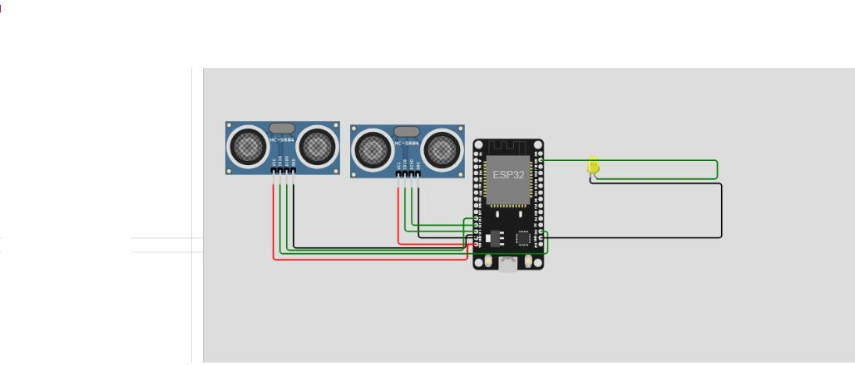

**SCHEMATICS:**

* DataIngestion
* Dataanalysis
* Optimizationengine
* Userinterface
* IOTinfrastructure
* Integrationwithmultimodetransport

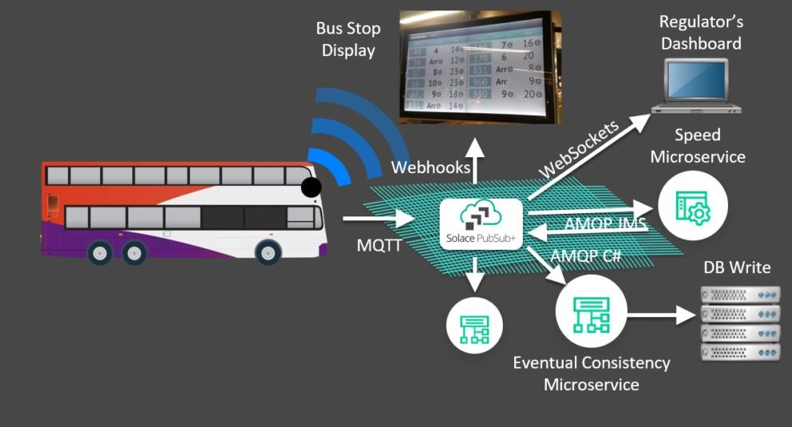

# SCREENSHOTSOFIOTSENSORS:

ULTRASONIC SENSORS:ultrasonic sensor emits high-frequency sound waves and measures the time it takes for themto bounce offanobject and return, enabling accurate distance measurement. These sensorsarenon-contact,versatile,andcommonlyused inapplicationslikeroboticsandobstacledetection

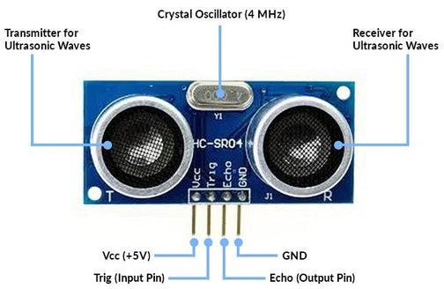

# TRANSITINFORMATIONPLATFORM:

A transit information platform in the context of public transport optimization typically refers to a systemorsoftwaresolutiondesignedtoimprovetheefficiencyandeffectivenessofpublic transportation services. These platforms are often used bypublic transit agencies, cities, or companies to manage and optimize various aspects of their public transportation operations.

* Real-timeData Integration:

Transit informationplatformsoftenincorporatereal-timedatafromvarioussources, includingGPS- equipped vehicles, passenger counts, and weather conditions, to provide up-to-date information to both operators and passengers.

* RoutePlanningandOptimization:

Theyhelp indesigningandoptimizingbusortrainroutestominimizetraveltime, reducecongestion, and enhance overall service efficiency.

* Scheduling:

Theseplatformscanassist increatingandmanagingtransitschedulesthatbalanceservicefrequency and capacity while minimizing operational costs.

* PassengerInformationSystems:

For the benefit of passengers, transit information platforms often provide real-time arrival and departureinformation,servicealerts,andtripplanningtoolsviavariouschannels, includingmobile apps, websites, and electronic displays at transit stops.

* FareManagement:

Theycanhandleticketingandpaymentsystems, includingcontactlesspaymentoptionsandfare integration with multiple modes of transportation.

* Analyticsand Reporting:

Theseplatformsprovide valuable insightsthroughdataanalysis,whichcaninformdecision-making, performance evaluation, and future planning.

* EnvironmentalandSustainabilityConsiderations:

Someplatformsmayinclude featuresto supportenvironmentallyfriendlypractices,suchaselectric vehicle adoption or route optimization for reduced emissions.

These transit information platforms can significantly improve the quality of public transportation services,enhancetheoverallpassengerexperience,andcontributetomoresustainableandefficient urban mobility. They are an important tool for modernizing and optimizing public transport systems in cities around the world.

# REAL–TIMEDATADISPLAY:

Real-timedatadisplayreferstothecontinuousand immediatepresentationofdataasit isgenerated orupdated,allowing usersto monitor and analyze informationas it changes inrealtime. Thisconcept is essential in various fields, including finance, IoT (Internet ofThings), monitoring and controlsystems, and data analytics

## DataSources:

Real-timedatacancome fromvarioussources,suchassensors,databases,streamingAPIs,oruser inputs. These sources continuously provide updates or new data points.

## DataProcessing:

Dataprocessing isnecessaryto validate,clean,andtransformthe incomingdatainto aformat suitable for display. This step might involve filtering, aggregating, and calculating metrics.

## Visualization:

Themost commonwayto displayreal-timedataisthroughvisualizationssuchascharts, graphs, dashboards, and heatmaps. These visuals make it easier to understand and interpret the data quickly.

## UserInterface:

Real-timedatadisplayoftenincludesauser interfacethat allowsusersto interactwithand customizethewaytheyviewthedata.Thiscanincludezooming,panning,filtering,andselecting specific time periods.

## Alerting:

Real-timedatasystemsmayincludealerting mechanismstonotifyuserswhencertainconditionsor thresholds are met, allowing for quick response to important events.

## Security:

Ensuringthesecurityand integrityofreal-timedataiscrucial,assensitive informationmaybe involved. Implementing authentication, authorization, and encryption is essential.

## Use Cases:

Real-timedatadisplayisused inawiderangeofapplications, includingstockmarkettrading platforms, weather monitoring, social media analytics, and industrial control systems.

To implement a real-time data display system, you'll need a combination of software tools, databases, and visualization libraries, depending on your specific requirements and technology stack. Populartoolsandframeworksforreal-timedatadisplayinclude ApacheKafka,Elasticsearch,Grafana, and various JavaScript libraries for building interactive web-based dashboards .

# IMPROVEPUBLICTRANSPORTATIONSERVICESANDPASSENGEREXPERIENCE:

Areal-timetransit informationsystemplaysacrucialrole in improvingpublictransportation services and enhancing the passenger experience in several ways:

## AccurateArrivalInformation:

Real-timetransit systemsprovideaccurateandup-to-dateinformationabout whenthenext bus, tram, subway, ortrain will arrive. Passengers canplantheir journeys more efficiently, reducing wait times and minimizing uncertainty.

## Reduced WaitTimes:

Passengerscancheckreal-timeschedulesandarrivalpredictionsthroughmobileappsordigital displays at transit stops. This reduces the time passengers spend waiting for transportation and makes public transit more convenient.

## OptimizedRoute Planning:

Real-timesystemscansuggest thebest routesandconnectionsbasedonreal-timedata,helping passengers choose the most efficient and cost-effective options for their journeys.

## CrowdManagement:

Byprovidinginformationonvehicleoccupancyandexpectedpassenger loads,transit agenciescan helppassengerschooselesscrowdedoptionsor plantheir tripsduringoff-peakhours, improvingcomfort and safety.

## ServiceAlertsandUpdates:

Real-timesystemscanpushnotificationstopassengersaboutservicedisruptions,delays,or changes in real-time. This keeps passengers informed and minimizes inconveniences caused by unexpected disruptions.

## AccessibilityFeatures:

Real-timesystemscanprovideinformationaboutaccessibilityfeaturesforpassengerswith disabilities, ensuring they have a smooth experience when using public transportation.

## Multi-ModalIntegration:

Some real-time transit systems integrate various modes of transportation, including buses, subways, trams, and even shared mobility options like ride-sharing or bike-sharing. This seamless integrationenhancesthepassengerexperienceand encouragestheuseofpublictransit fortheentire journey.

## User-FriendlyApps:

Transit agenciesoftenprovidemobileappsthatofferreal-timeinformation,routeplanning,and payment options. These apps can be user-friendlyand enhance the passenger experience bysimplifying ticketing and making transit information easily accessible.

## ImprovedSafetyand Security:

Real-timedatacanbeusedfor monitoringandensuringthesafetyandsecurityofpassengers.

Surveillancecameras,emergencycommunicationsystems,andreal-timetrackingcanhelptransit agencies respond quickly to incidents.

## ReducedEnvironmentalImpact:

Byhelpingpassengersmake more informedtransportationchoicesandreducingcongestionon the roads, real-time transit information systems contribute to reducing greenhouse gas emissions and environmental impact.

DataforServiceImprovement:

Transit agenciescanusereal-timedatatomonitortheperformanceoftheirservicesand make data-driven decisions to improve operations, route planning, and service quality.

## CustomerFeedback:

Real-timesystemscaninclude featuresfor passengersto provide feedbackorreport issues. This feedbackloophelpstransitagenciesaddresspassengerconcernsandcontinuouslyimprovetheirservices.

## IncreasedRidership:

Amore predictable, convenient, and efficient public transportation system is likely to attract moreriders, reducingthenumberofprivatevehiclesontheroadandeasingcongestioninurbanareas.

In summary, a real-time transit information system enhances the passenger experience by providing timelyand accurate information, reducing wait times, and offering an overall more convenient and reliable transportation service. It not only benefits passengers but also helps transit agencies optimize their operations and contribute to more sustainable and efficient urban transportation systems